**1'S AND 2'S COMPLEMENT FOR 16 BIT**

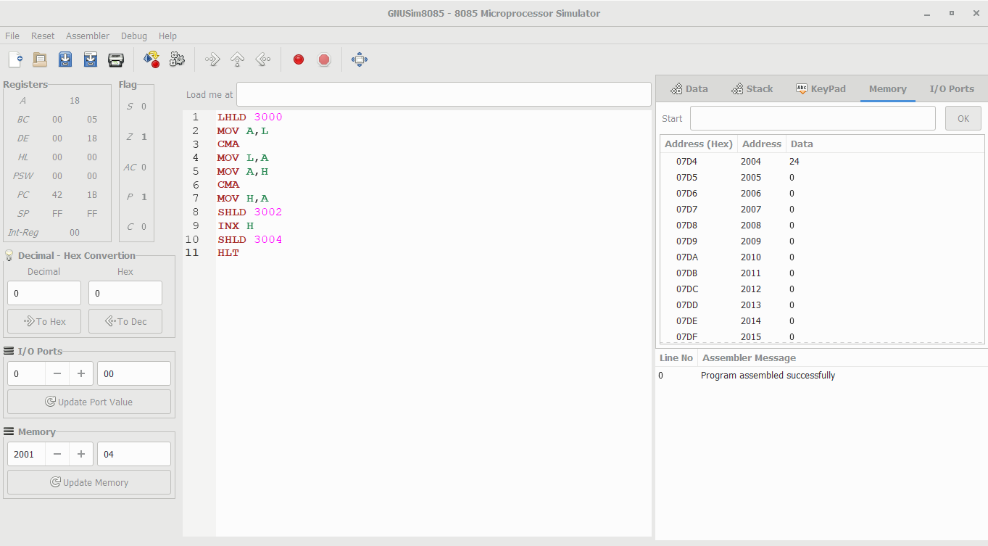

**1'S AND 2'S COMPLEMENT FOR 8 BIT**

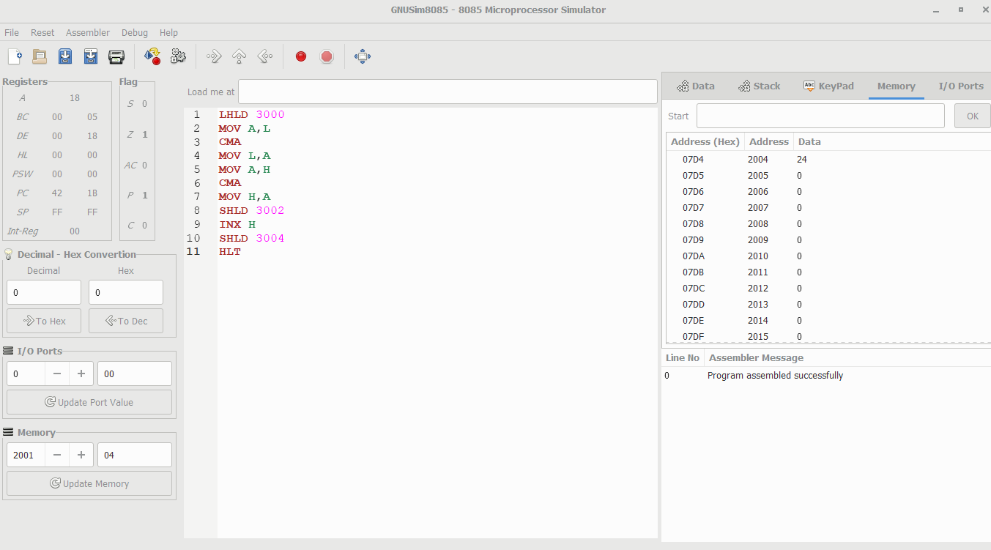

**16 BIT ADDITION 2**

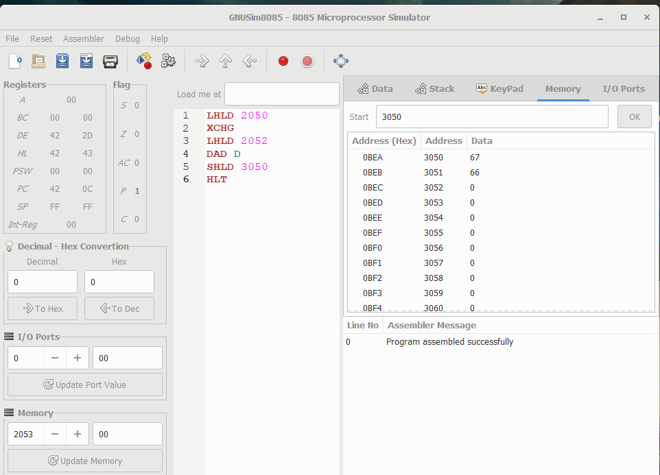

**16 BIT ADDITION**

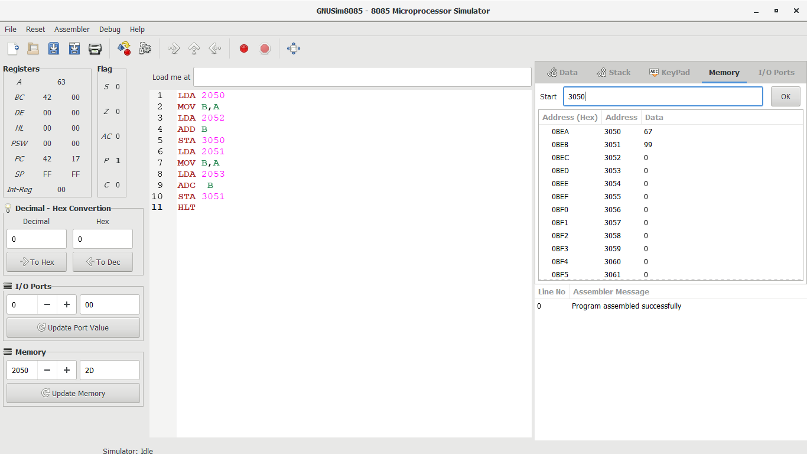

**16 BIT DIVISION**

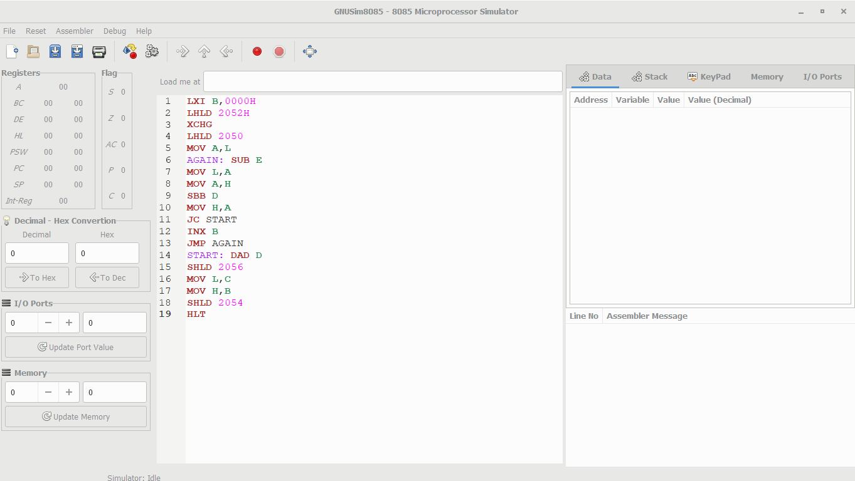

**16 BIT MULTIPLICATION**

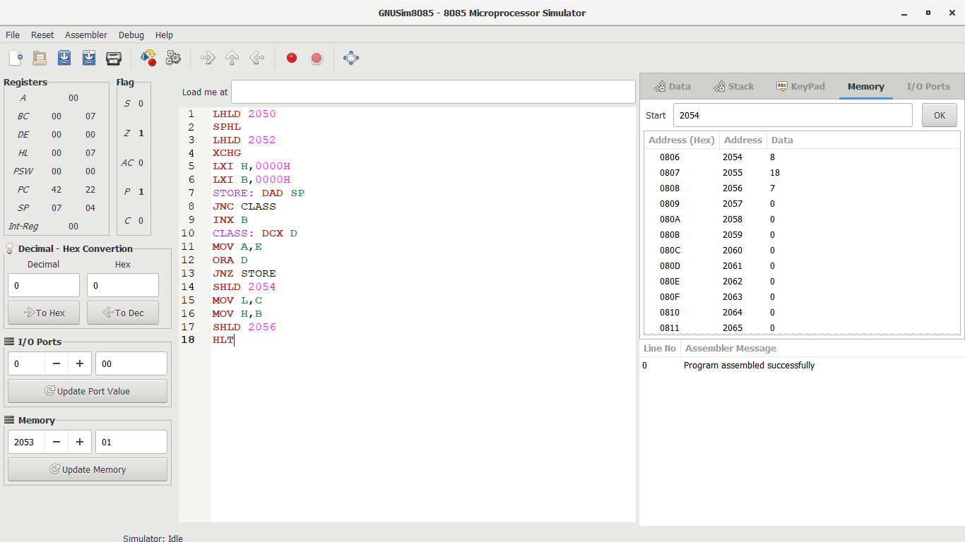

**16 BIT SUBTRACTION**



**8 BIT ADDITION**

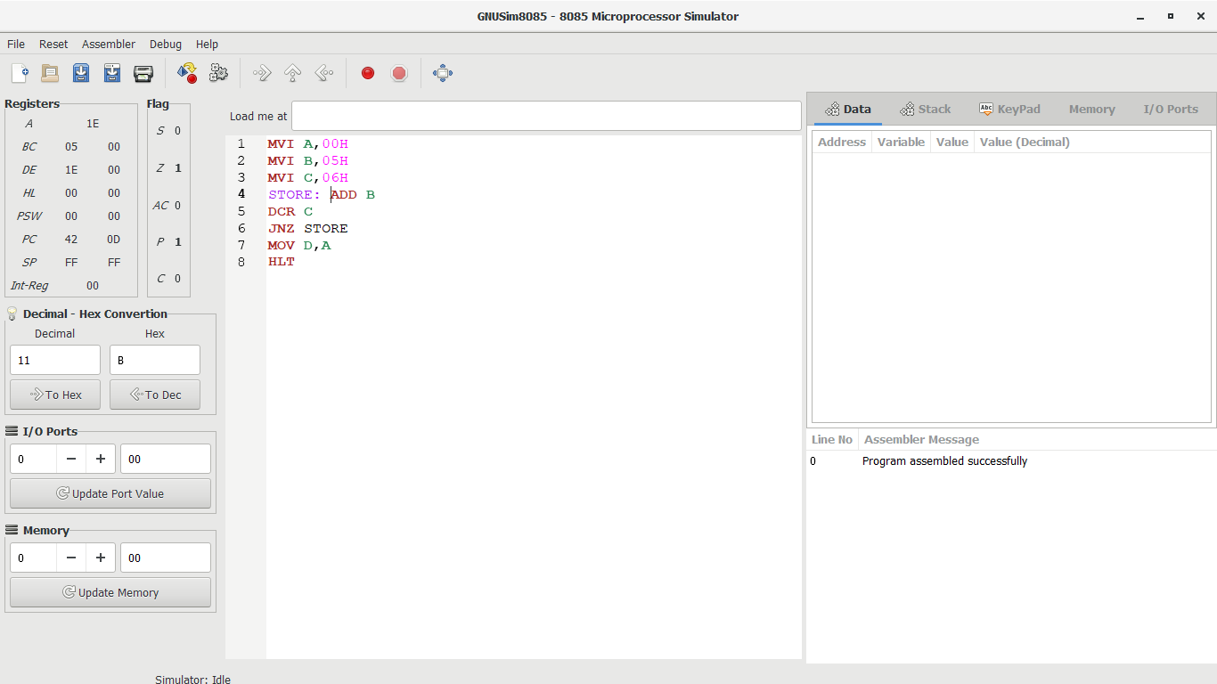

**8 BIT DIVISION**

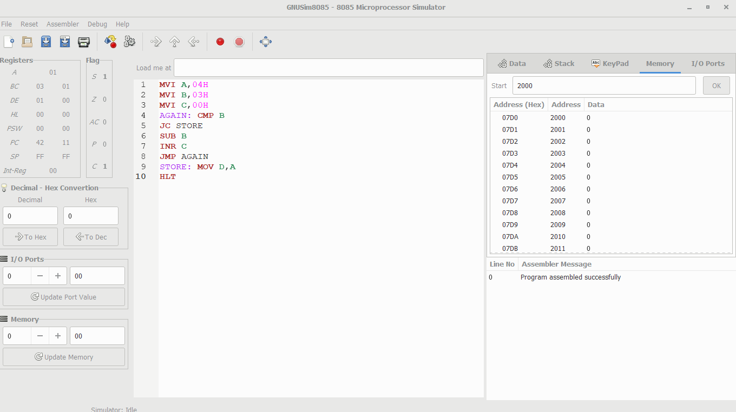

**8 BIT MULTIPLICATION**



**8 BIT SUBTRACTION**

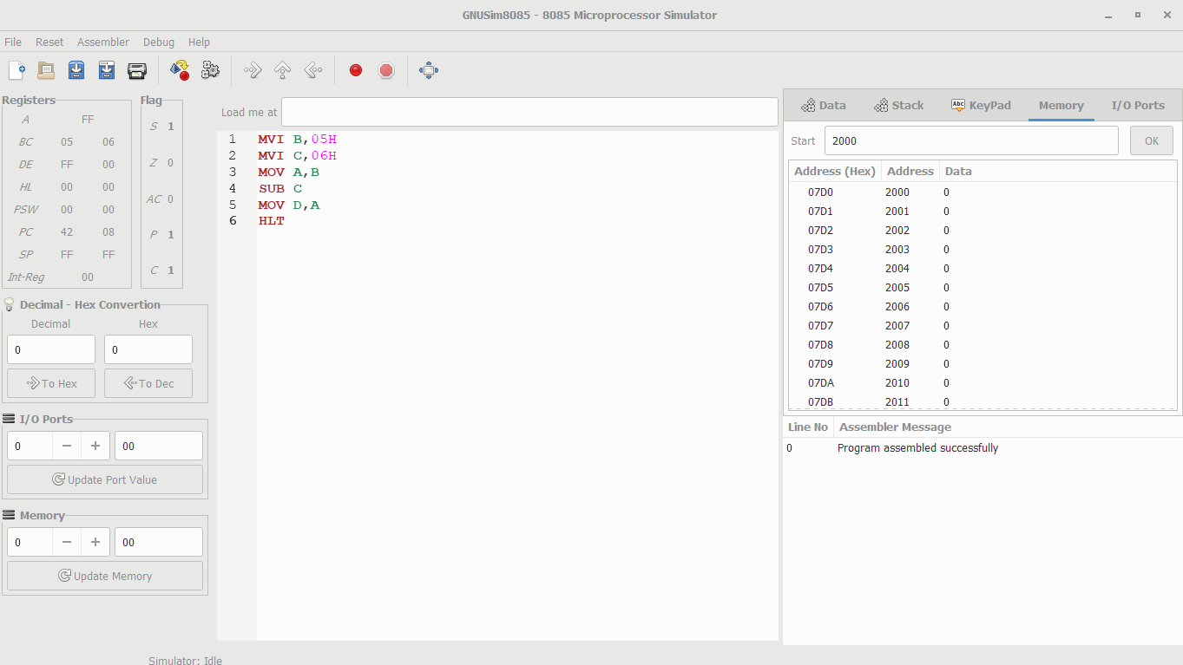

**ADDITION FOR 8 BIT**

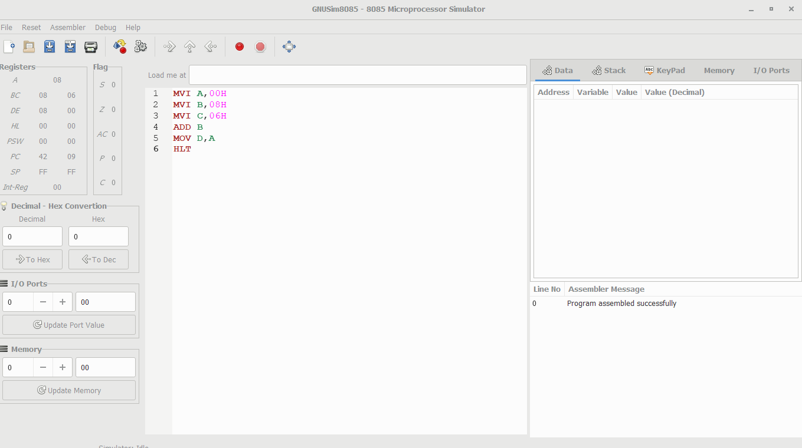

**ADDITION OF N NUMBER**

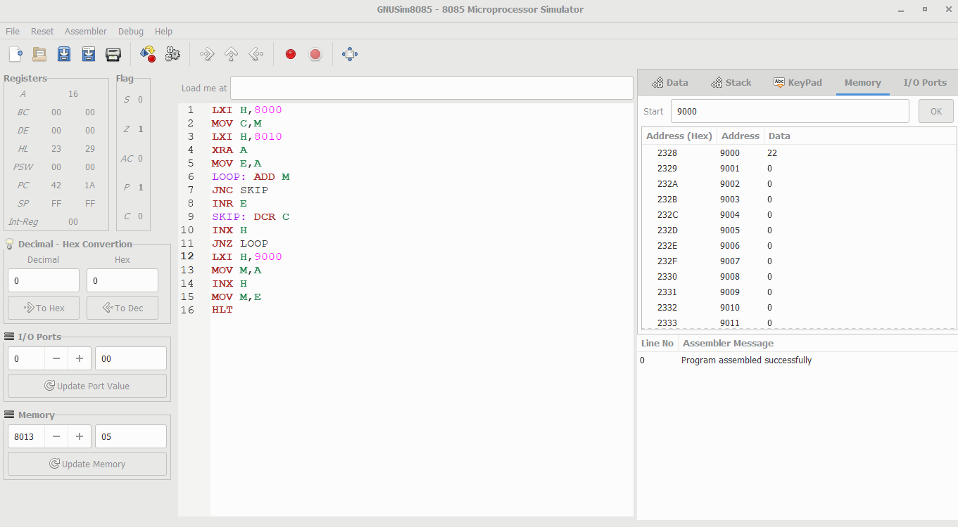

**AND GATE OPERATION**

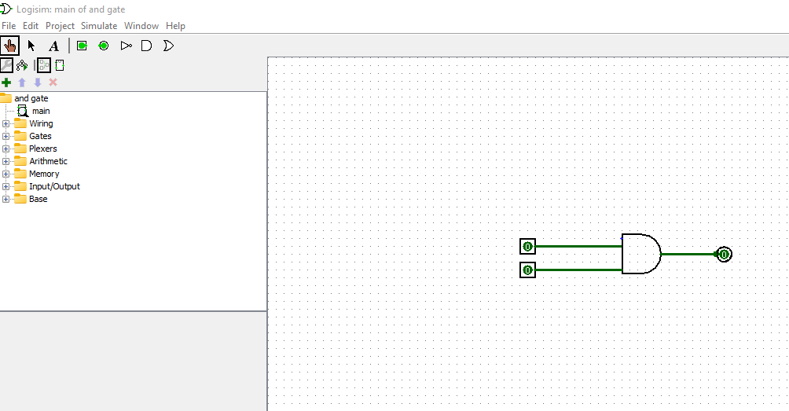

**AND OPERATION**

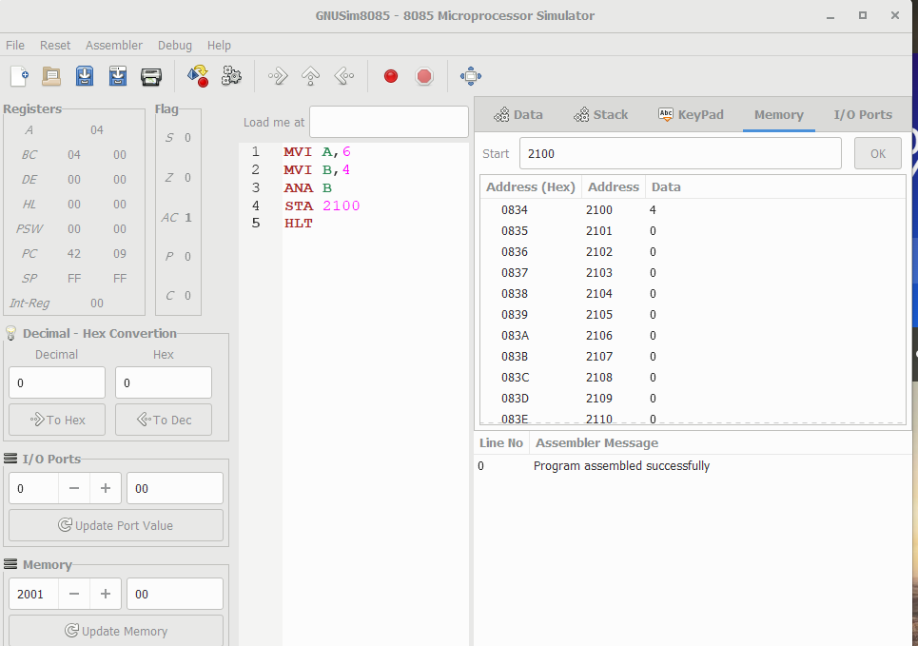

**ASCENDING ORDER IN 8085**

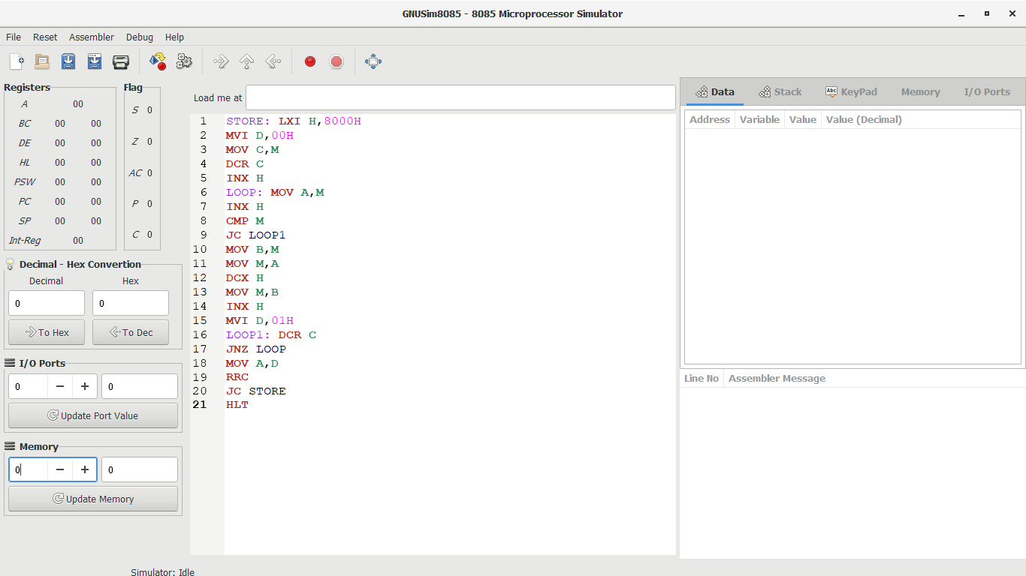

**DESCENDING ORDER IN 8085**

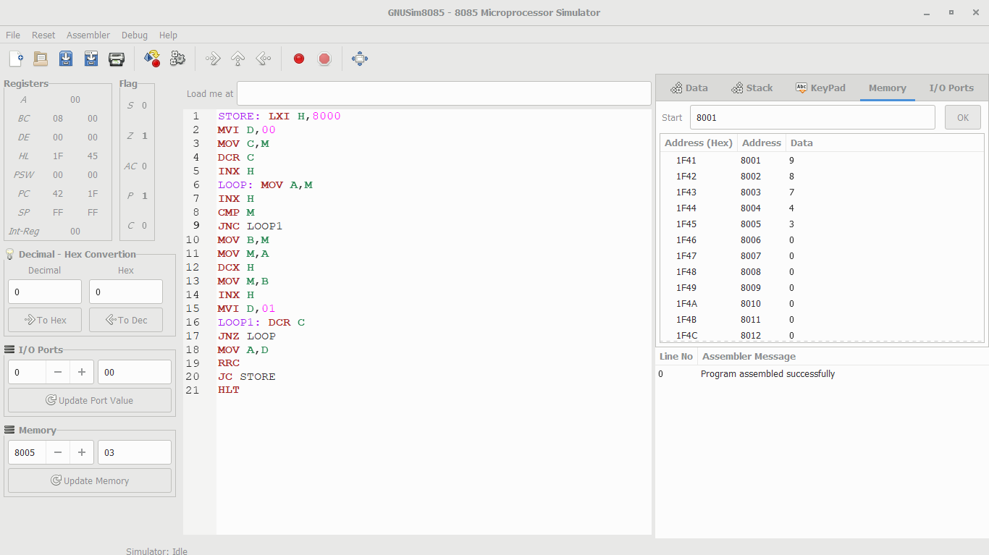

**FACTORIAL IN 8085**

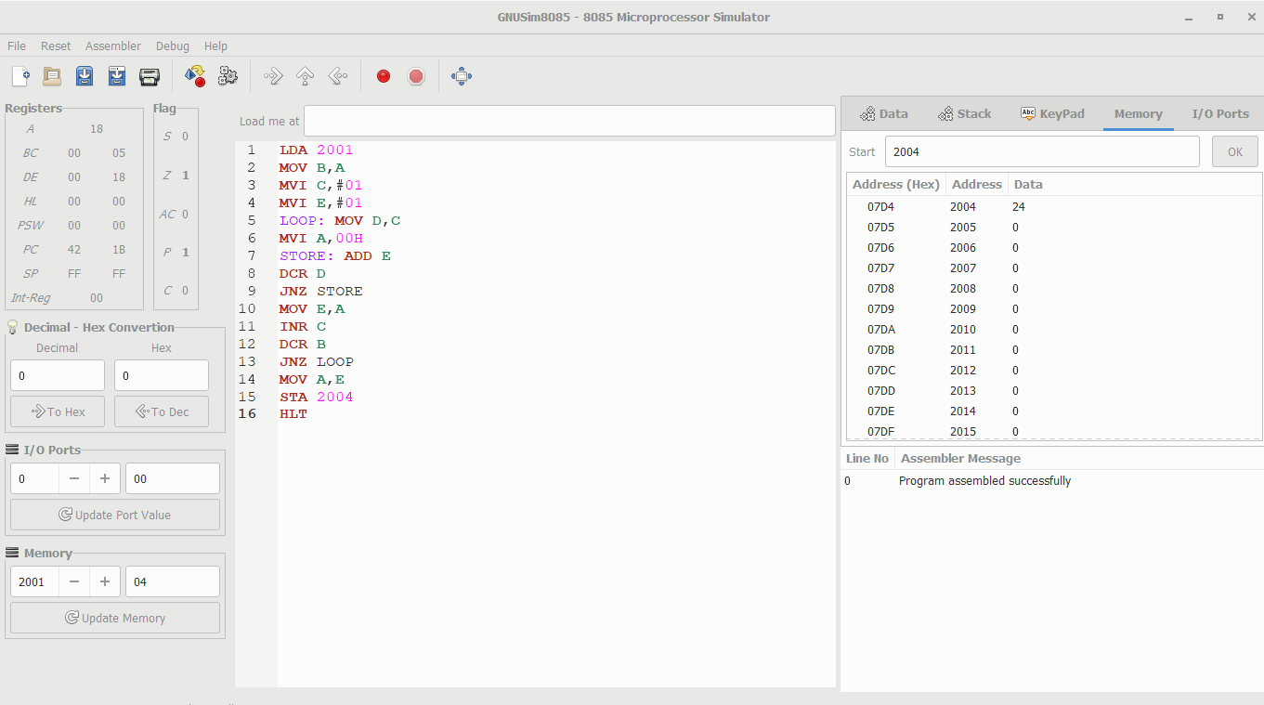

**FULL ADDER**

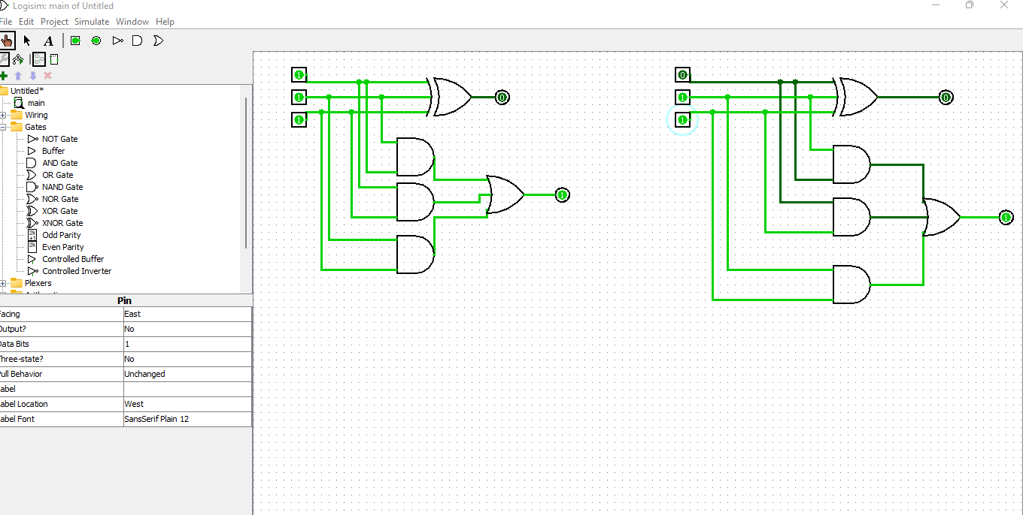

**FULL SUBTRACTOR**

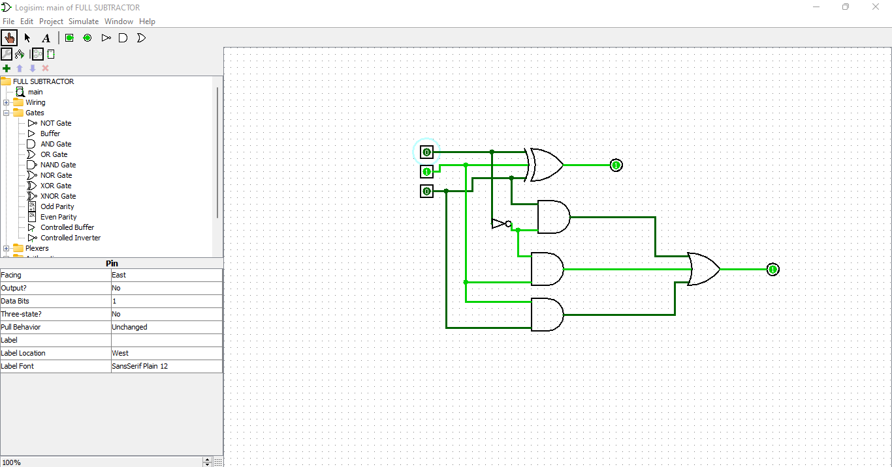

**HALF ADDER**

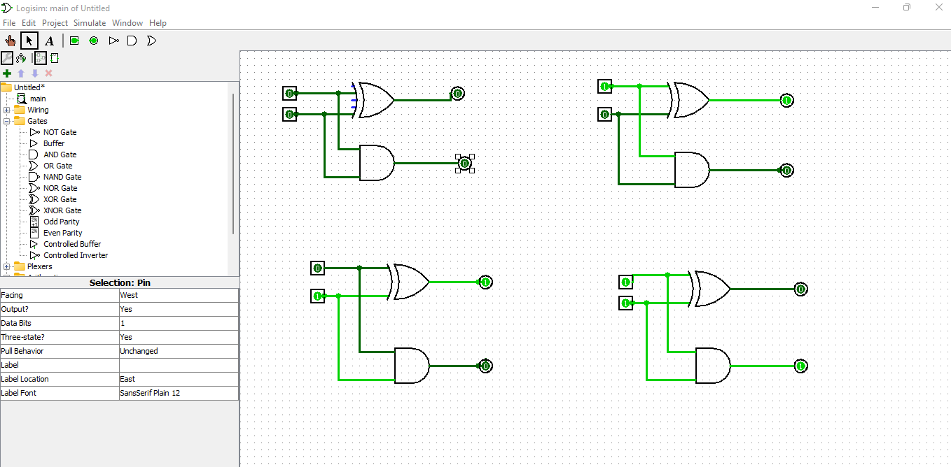

**HALF SUBTRACTOR**

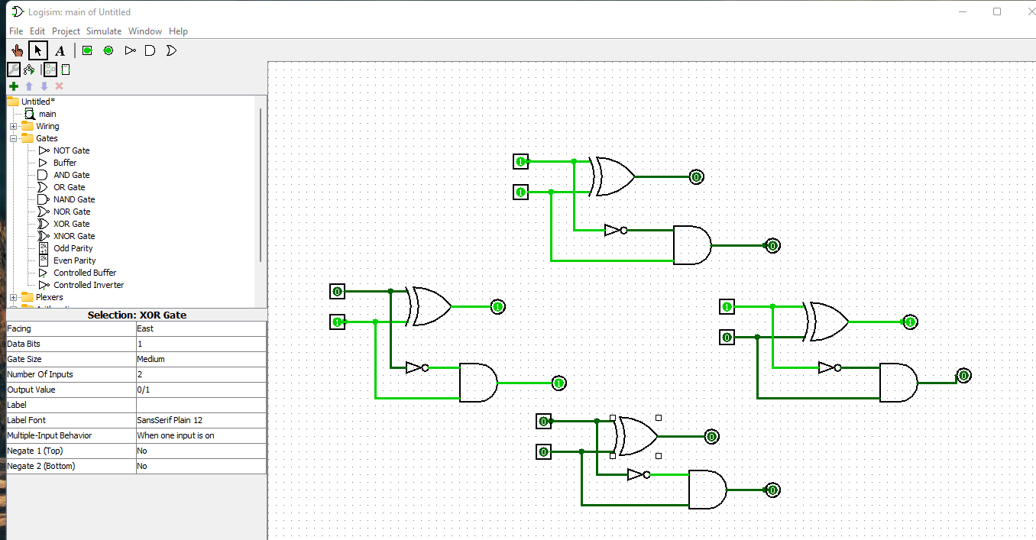

**LARGEST NUMBER FOR 2 DIGITS**

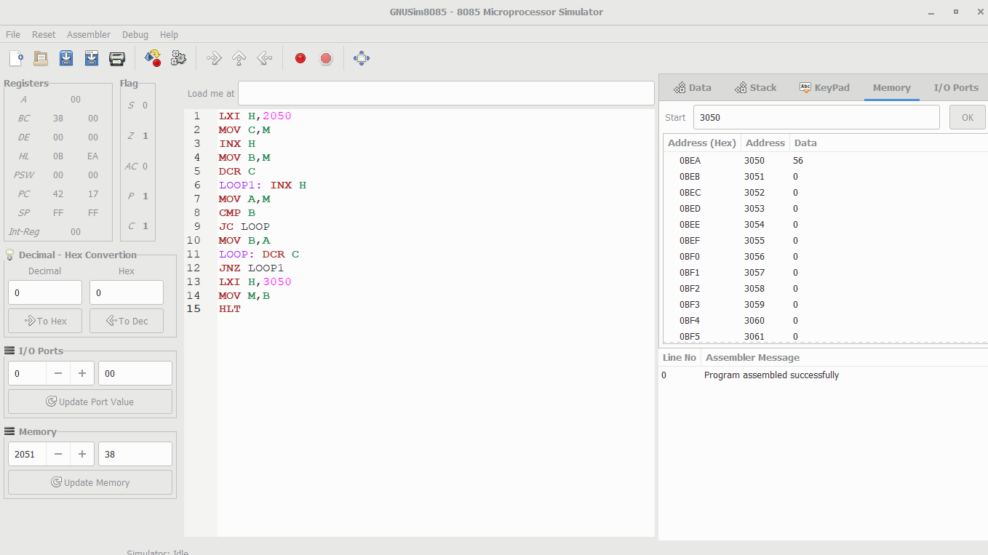

**NAND GATE**

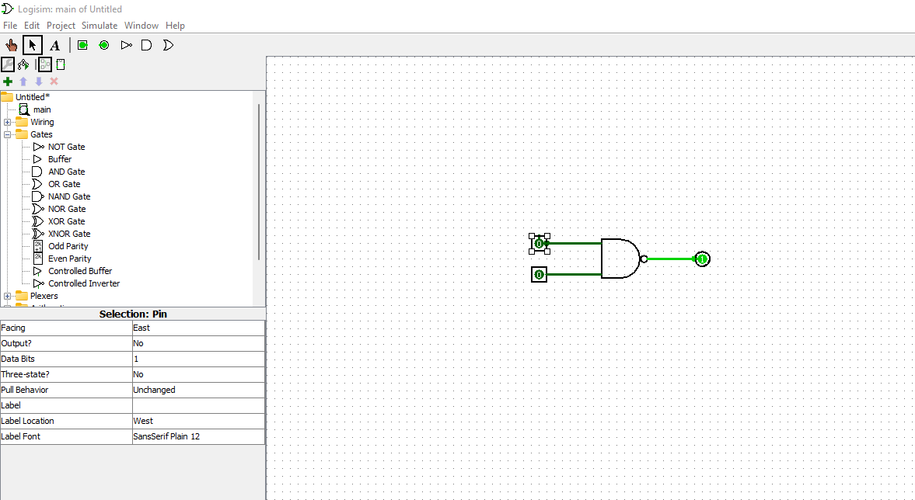

**NOR GATE**

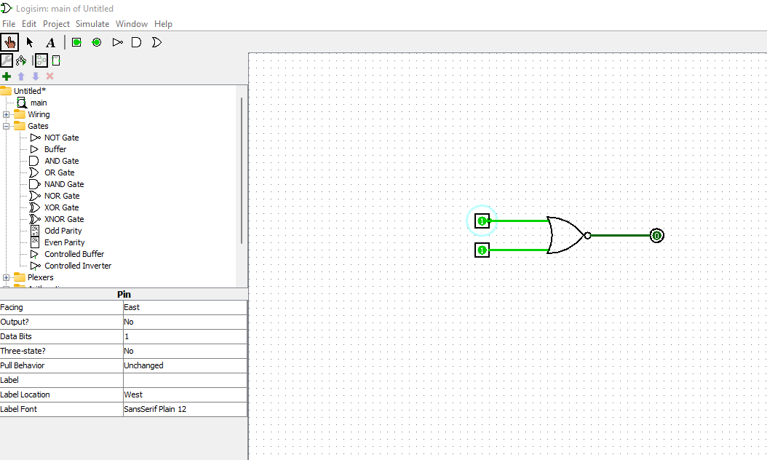

**NOT GATE**

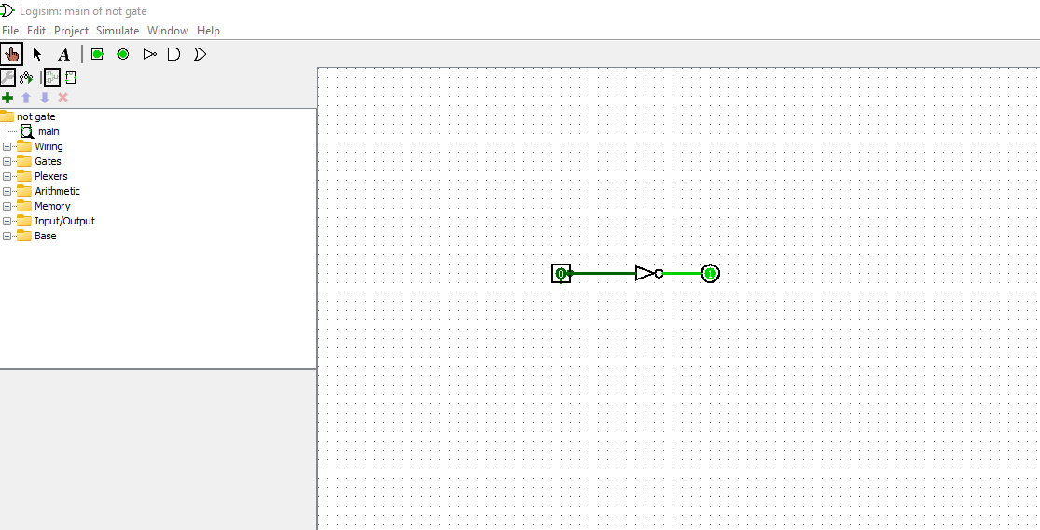

**OR GATE OPERATION**

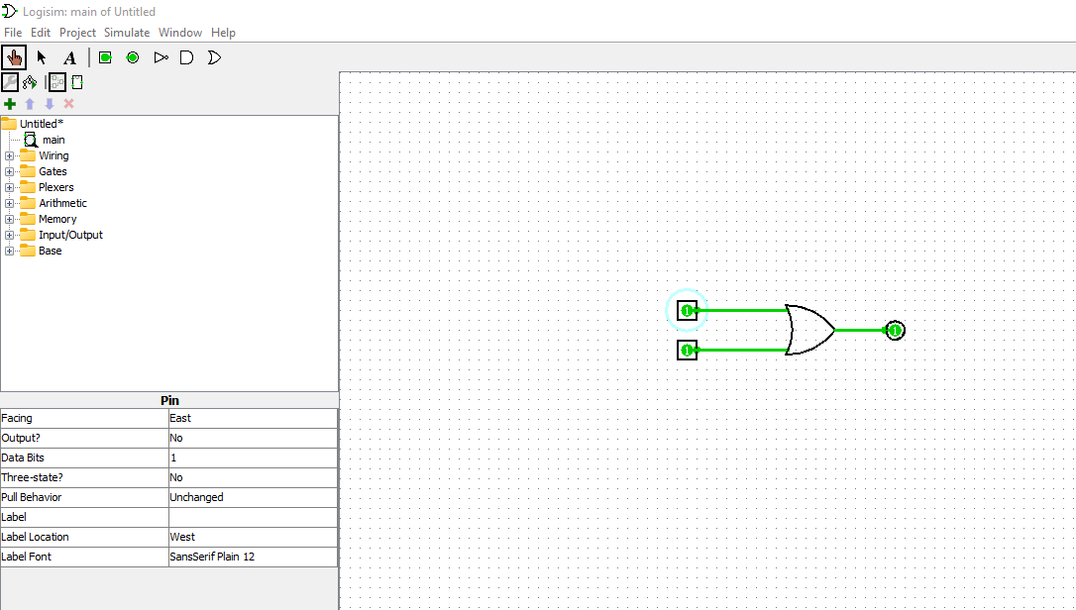

**OR OPERATION**

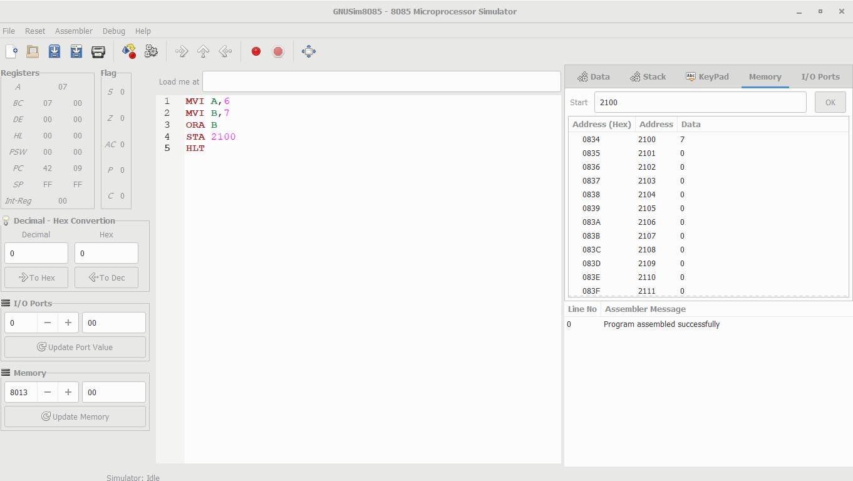

**ROTATE LEFT SHIFT OPERATION**

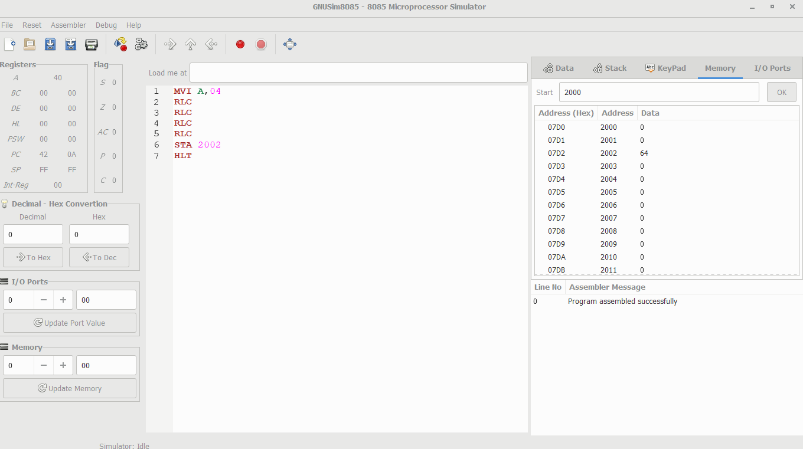

**ROTATE RIGHT SHIFT OPERATION**

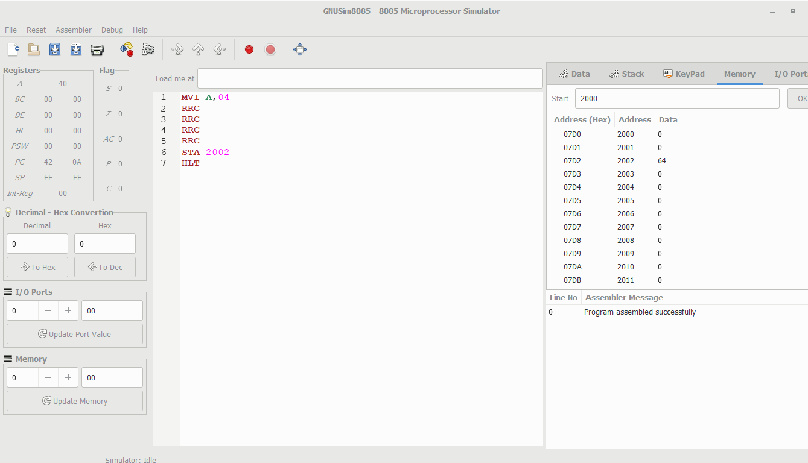

**SMALLEST NUMBER IN ARRAY**



**SQUARE OF THE NUMBER**

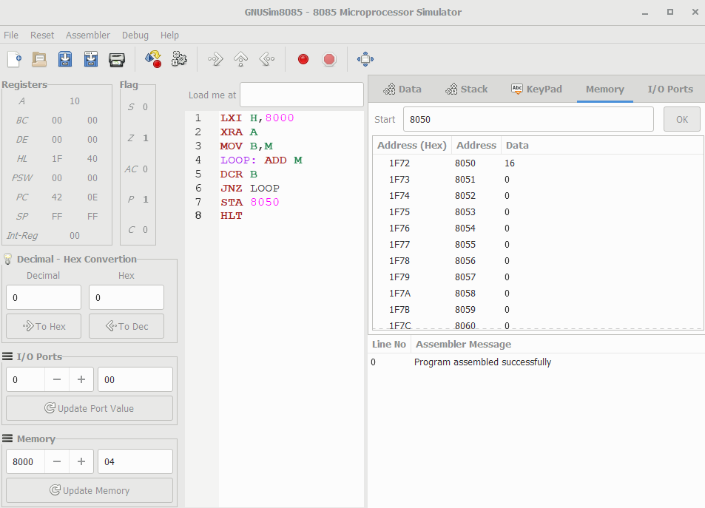

**SWAP**

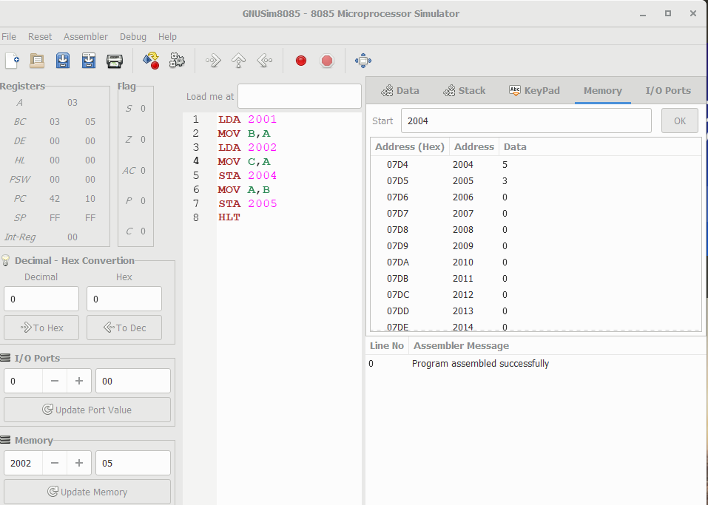

**TRANSFERRING BLOCKS IN 8085**

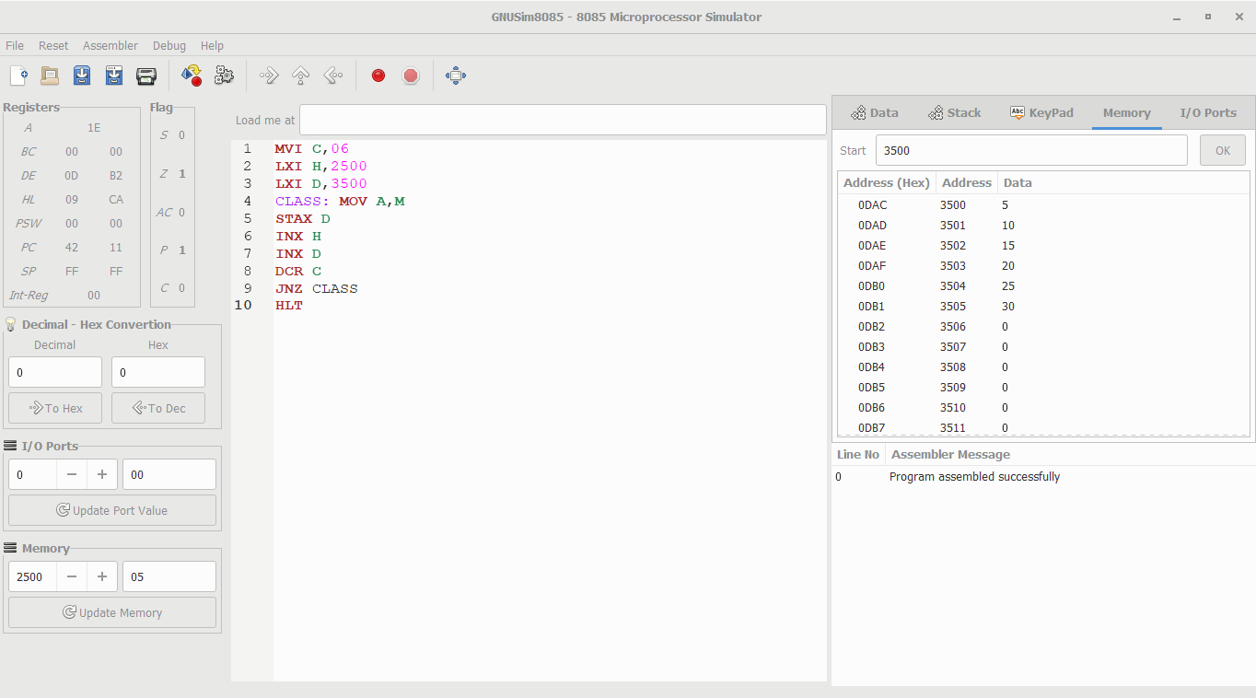

**XOR GATE OPERATION**

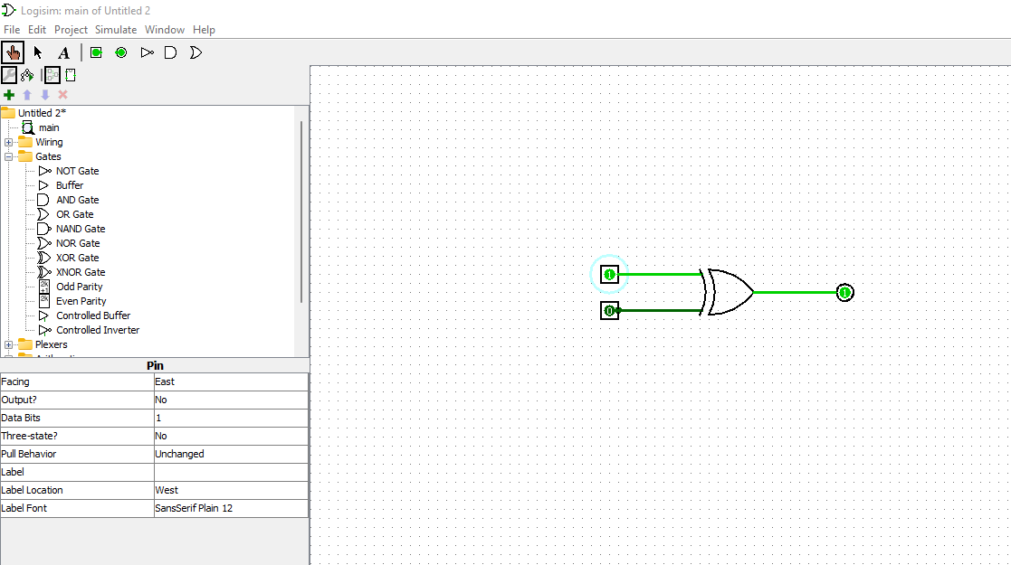

**XOR OPERATION**

